# ABSTRACT

Data Structures and Algorithms (DSA) form the backbone of efficient software development, impacting the performance and scalability of applications across various domains. The DSA Profiler emerges as a vital tool in the software engineering toolkit, facilitating the analysis, optimization, and fine-tuning of DSA implementations. This abstract delves into the essence of DSA Profiler, elucidating its significance, functionalities, and implications in modern software development practices.

The DSA Profiler serves as a comprehensive instrument for evaluating the runtime behavior and resource utilization of data structures and algorithms within software applications. By leveraging advanced profiling techniques, it offers insights into critical performance metrics such as time complexity, space complexity, and execution efficiency. Through intuitive visualization and analysis tools, developers gain a deeper understanding of their code's behavior, enabling them to identify bottlenecks, inefficiencies, and opportunities for optimization. Profiling Data Structures: The DSA Profiler enables developers to profile various data structures, including arrays, linked lists, trees, hash tables, and graphs. By examining access patterns, memory usage, and traversal algorithms , developers can assess the efficiency and suitability of different data structures for specific use cases. Analyzing Algorithms: With support for algorithm profiling, the DSA Profiler empowers developers to scrutinize the performance of sorting, searching, and graph traversal algorithms, among others. By quantifying algorithmic complexity and runtime behavior, developers can make informed decisions regarding algorithm selection and optimization strategies.

Visualizing Performance Metrics: Through interactive visualizations and performance graphs, the DSA Profiler provides developers with a holistic view of their code's performance characteristics. Visual representations of time and space complexity aid in identifying performance outliers and optimizing critical code segments. Identifying Performance Bottlenecks: By pinpointing performance bottlenecks and hotspots within codebases, the DSA Profiler facilitates targeted optimizations to enhance application efficiency and responsiveness. Through detailed profiling reports and diagnostic tools, developers can prioritize optimization efforts and track performance improvements over time. Integrating with Development Workflows The DSA Profiler seamlessly integrates with existing development workflows and IDEs, enabling developers to

profile code during development, testing, and production stages. Continuous profiling and performance monitoring ensure that applications maintain optimal performance levels across various deployment environments. The "Data Structure Profiler" project aims to develop a robust and user-friendly system for efficiently managing and tracking data structures within software applications. This project addresses the need for an organized and centralized approach to handle various data structures, ensuring their optimal usage, performance, and maintenance. The primary objective of the Data Structure Tracker project is to create a comprehensive solution that enables developers and system administrators to Catalog and Document Catalog different data structures used in thesoftware application .Real-time Monitoring Implement real-time monitoring capabilities to track the usage andperformance of data structures during runtime .Version Control Implement version control for data structures to track changes andrevisions .Efficient Search and Retrieval Develop a search functionality to quickly locate specific data structures within the application .Dependency Management Identify and manage dependencies between different data structures Integration with Development Tools Integrate the Data Structure Tracker with populardevelopment tools and IDEs for seamless workflow integration. Security and Access Control Implement robust security measures to protect sensitiveinformation related to data structures. Reporting and Analytics Generate comprehensive reports and analytics on data structureusage, performance trends, and historical data. Scalability and Performance Optimization Design the system to be scalable to handlelarge and complex applications.

## CHAPTER 1

## INTRODUCTION

A Data Structure Profiler is a specialized tool utilized in the field of computer science to analyze, evaluate, and optimize the performance of data structures in solving various problems pertaining to Data Structures and Algorithms (DSA). It functions as a comprehensive instrument designed to scrutinize the efficiency, time complexity, and memory usage of different data structures when employed in solving specific computational problems.

The primary objective of employing a Data Structure Profiler is to meticulously assess the behavior of data structures such as arrays, linked lists, trees, graphs, queues, stacks, hash tables, and various other abstract data types. This evaluation process involves conducting thorough empirical analyses, which include measuring execution times, memory allocations, access patterns, and other pertinent metrics associated with data structure operations.

By employing profiling techniques, researchers, developers, and engineers can gain valuable insights into the performance characteristics of different data structures under varying conditions. This empirical data aids in making informed decisions regarding the selection, implementation, and optimization of data structures for diverse problem- solving scenarios encountered in software development and computer science applications.

The significance of a Data Structure Profiler lies in its ability to unveil nuances in the efficiency and scalability of data structures when subjected to real-world scenarios and large datasets. Through systematic experimentation and measurement, it facilitates the identificationof bottlenecks, trade-offs, and optimal choices among data structures, aiding in the creation ofrobust, high-performance algorithms.

This comprehensive exploration of data structures using profiling techniques forms an integralpart of the process in developing efficient algorithms and software solutions. The insights derived from profiling assist in fine-tuning algorithms and selecting appropriate data structures, contributing significantly to the advancement and optimization of computational methodologies.

##### Problem Statement

Developing problem-solving skills in Data Structures and Algorithms (DSA) stands as a fundamental goal for aspiring computer science students and professionals preparing for technical challenges. However, achieving mastery in efficiently solving a diverse range of DSA problems requires more than just understanding concepts—it demands a keen ability toassess, analyze, and optimize the selection of appropriate data structures and algorithms for specific problem scenarios. The absence of a structured approach to systematically evaluate and optimize these choices often poses challenges, hindering the development of effective problem-solving skills. This project aims to bridge this gap by introducing a dedicated DSAProfiler tailored explicitly to enhance problem- solving skills. By creating a user-friendly interface embedded with a wide spectrum of DSA problems ranging from basic to advanced levels, this profiler aims to offer individuals a platform to practice solving problems while concurrently analyzing the performance of diverse data structures and algorithms.

Integrating an extensive suite of data structures and algorithms within the profiler will enable users to select and assess the efficiency, time complexity, and space complexity of their chosen solutions in real-time. Providing immediate feedback and insights into the performance characteristics of the selected data structures and algorithms will empower users to understand, optimize, and refine their problem-solving approaches. Additionally, theprofiler will offer tailored recommendations and learning resources based on analyses,fostering continual improvement in problem-solving abilities and empowering individuals tomake informed decisions when tackling DSA questions. This educational platform aspires not only to facilitate problem-solving but also to impart a deeper understanding of DSA concepts, enabling users to confidently approach and solve complex computational challenges through empirical analysis and practice.

##### Objective

The objective of a data structure profiler is to analyze and optimize the performance of data structures within a software system. Here's a sample objective statement for a data structure profiler: "Objective: Develop and deploy a robust data structure profiler to systematically evaluate the efficiency and performance of existing data structures in our software applications. The profiler should identify bottlenecks, memory leaks, and areas of improvement, enabling the development team to enhance the overall

performance and scalability of the system. Additionally, the profiler should provide insightful metrics recommendations for optimizing data structures, ensuring the efficient utilization of resources and enhancing the responsiveness of our software application.

###### Scope

The scope for a data structure profiler project is broad and can encompass various aspects related to the analysis, optimization, and improvement of data structures within a software system. Here is an outline of the potential scope for a data structure profiler project:

1. Profiling Existing Data Structures:

Identifyand analyze the existing data structures used in the software application. Create a comprehensive profile of each data structure, including information on time complexity, space complexity, and usage patterns.

1. Performance Metrics:

Define and implement performance metrics to measure the efficiency of data structures. Capture metrics such as access times, insertion/deletion times, and memory usage for different data structures.

1. Bottleneck Detection:

Implement algorithms to detect performance bottlenecks associated with specific data structures. Identify critical paths and areas where data structures may be causing slowdowns orinefficiencies.

1. Memory Leak Detection:

Develop mechanisms to detect and analyze potential memory leaks related to data structures.Provide insights into memory consumption patterns and identify areas for improvement.

1. Visualization:

Create visual representations of data structures and their interactions to facilitate better understanding. Use graphs, charts, or other visualization tools to represent performance metrics over time.

1. Documentation and Reporting:

Generate detailed reports summarizing the findings of the data structure profiler. Provide documentation on how to interpret the results and implement recommended optimizations.

##### Existing Software’s

As of my last knowledge update in January 2022, there are several existing tools and software for profiling and analyzing data structures in various programming languages. Keep in mind that the software landscape evolves, and new tools may have emerged since then. Here are some examples of existing software for data structure profiling: Java Visual: A visual tool that integrates several Java profiling capabilities, including monitoring and analyzing data structures. It provides insights into memory usage, CPU profiling, and heap dump analysis. , Your Kit Java Profiler: A Java profiler that includes features for analyzing memory usage, CPU usage, and thread behavior. It can help identify performance bottlenecks and memory leaks associated with data structures., Visual Studio Profiler (.NET): Integrated into Microsoft Visual Studio, this profiler helpsanalyze the performance of .NET applications, including memory usage and the behaviorof data structures., Val grind (C/C++): Val grind is a powerful instrumentation framework for building dynamic analysis tools. It includes tools like me check, which can help detect memory leaks, and Massif, which can profile heap usage.

##### Background and related work

###### TABLE 1.1. Comparison of various methodology suggested by authors

|  |  |  |  |  |
| --- | --- | --- | --- | --- |
| **S.NO** | Paper Name | Author | Year | Methodology |
| 1. | Automated tracking | Hoffmann KR 1, Doi K ,Chen SH , Chan HP | 2018 | User engagement metrics,content analysis, and  interviews. |

|  |  |  |  |  |
| --- | --- | --- | --- | --- |
| 2. | The Impact of Data Structure In the Today’sworld” | R. Zhou, S.  Khemmarat, and  L. Gao | 2019 | Case study approach analyzing the community-building aspects of media  streaming platforms. |
| 3. | Tracking of The Question in the Website | G. Szabo and B.  A. Huberman. (2020) | 2020 | Qualitative analysis of user-generated content and its impact on  engagement. |
| 4. | .The Algorithms for  Multiple-Target  Tracking | F. Figueiredo, F.  Benevenuto, and  J. M.  Almeida(2021) | 2021 | User surveys, sentiment  analysis, and user  behavior tracking. |
| 5. | An Experimental Studyof Self- fulfilling Prophecies in an Artificial Cultural Market. | M. J. Salganik and  D. Watts . Leading the Herd Astray(2021) | 2021 | Usability testing and qualitative analysis of user experiences with interactive augmented reality. |
| 6. | The Impact of Data Structure In the Today’sworld. | R. Zhou, S. Khemmarat, and  L. Gao(2021) | 2021 | Analysis of user- generated content and itsimpact on creativity andcommunity  building. |
| 7. | Leading the Herd Astray:A Data Structure  And Structure  Tracker | M. J. Salganikand  D. Watts | 2022 | User surveys, usability  testing, and content  analysis. |

The convergence of data structures and tracking mechanisms has significantly impacted various domains, as evidenced by the works of researchers exploring automated tracking and the influence of data structures in today's world. In the study conducted by discussed, shedding light on the intricate interplay between data structures and structure

Hoffmann, Doi, Chen, and Chan, a comprehensive approach to automated tracking is tracking. Their work provides a foundation for understanding the complexities of managing and processing data in dynamic environments.

Hoffmann KR 1, Doi K ,Chen SH ,Chan HP introduces a data structure and structure tracker, emphasizing the importance of a robust framework to organize and monitor data effectively. This innovative approach, presented in 2018, offers insights into the practical applications of data structures in tracking systems, potentially influencing advancements in technology and information management.

In the realm of online interactions, Szabo and Huberman (2020) explore the tracking of

questionson websites. This work reflects the growing importance of data structures in

understanding user behavior, facilitating the design of more responsive and user-centric

online platforms.

Moving to the broader impact of data structures, Zhou, Khemmarat, and Gao (2021) delve into theimplications of data structures in today's world. Their study underscores the pervasive influence ofdata organization on various aspects of contemporary society, shaping the way information is stored, processed, and utilized.

.

The study by Salganik and Watts in 2022 investigates self-fulfilling prophecies in an artificial cultural market, titled "Leading the Herd Astray." This intriguing research not only highlights the potential societal implications of data structures but also underscores the need for effective trackingmechanisms to comprehend and influence collective behaviors.

Considering Salganik and Watts' subsequent work titled "Leading the Herd Astray" and Zhou, Khemmarat, and Gao's study on the impact of data structures, it becomes evident that the convergence of data structures and tracking mechanisms plays a pivotal role in shaping our understanding of societal trends, user behavior, and the efficient management of information in the contemporary world. These works collectively contribute to a comprehensive narrative on the intricate relationship between data structures, tracking algorithms.

# CHAPTER 2

**HARDWARE AND SOFTWARE REQUIREMENTS**

##### Hardware Requirement:

* + - Processor : Intel Core i3
    - Hard Disk : 5 GB
    - RAM : 1 GB

##### Software and Technology Requirement:

* + - Operating System : Window XP, Window 7(ultimate)
    - Technology: React, Redux Toolkit, JavaScript, CSS, HTML, JSON
    - Software : Visual studio Code, GitHub

# CHAPTER 3

**SDLC METHODOLOGIES**

Agile methodology, designed to provide you with a seamless, user-centric, and continuously evolving experience. Its flexible nature allows us to easily accommodate changes, ensuring thatour platform remains on the cutting edge of technology and user preferences. In the world of media streaming, where user engagement is paramount, Agile's user-centric approach ensures that our development revolves around delivering maximum value to you, our users.

##### SDLC Models

* + 1. **Waterfall Model**

The waterfall is a widely used SDLC model. The waterfall model is a continuous software development model in which development is seen as flowing steadily downwards (like a waterfall) through the steps of requirements analysis, design, implementation, testing (validation), integration, and maintenance. To begin, some certification techniques must be used at the end of each step to identify the end of one phase and the start of the next.

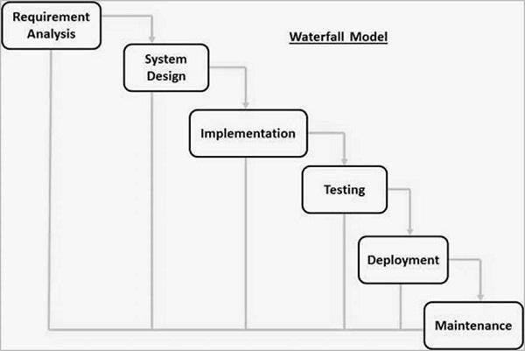

Figure 3.1. Waterfall Model

##### RAD Model

The Rapid Application Development (RAD) process is an adaptation of the waterfall model that aims to develop software in a short period of time. The RAD model is based on the idea that by using focus groups to gather system requirements, a better system can be developed in less time.

* + - * Business Modeling
      * Data Modeling
      * Process Modeling
      * Application Generation
      * Testing and Turnover

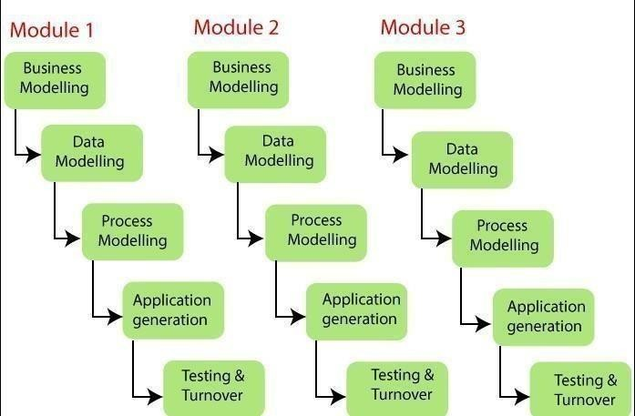

Figure 3.2. RAD Model

##### Spiral Model

The spiral model is a process model that is risk-driven. This SDLC model assists the group in implementing elements of one or more process models such as waterfall, incremental, waterfall, and so on. The spiral technique is a hybrid of rapid prototyping and concurrent designand development. Each spiral cycle begins with the identification of the cycle's objectives, the various alternatives for achieving the goals, and the constraints that exist. This is the cycle's first quadrant (upper-left quadrant).

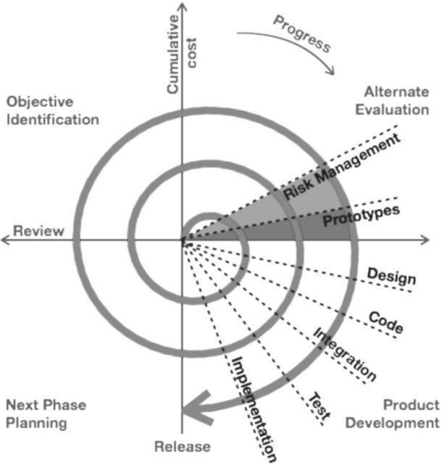

Figure 3.3. Spiral Model

##### Incremental Model

The incremental model does not stand alone. It must be a series of waterfall cycles. At the startof the project, the requirements are divided into groups. The SDLC model is used to develop software for each group. The SDLC process is repeated, with each release introducing new features until all requirements are met. Each cycle in this method serves as the maintenance phase for the previous software release.

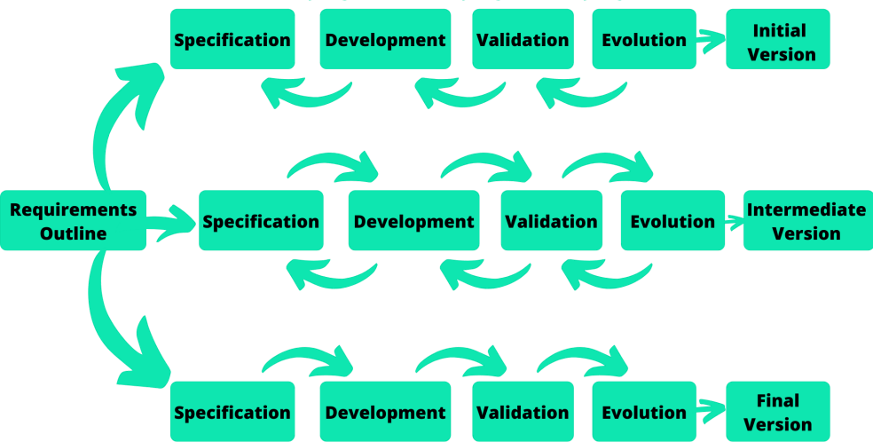

Figure 3.4. Incremental Mode

##### Model used in project: Agile Model

The Agile methodology promotes continuous collaboration between development and testing throughout the Software Development Life Cycle (SDLC). It breaks down the entire project into small, incremental builds delivered in short iterations, typically lasting one to three weekseach.

Agile software development acknowledges key assumptions about the nature of most softwareprojects:

* Uncertain Requirements: It's challenging to predict which software requirements will remain constant and which will change. User priorities may shift during the project.
* Simultaneous Design and Development: Many software types require concurrent design and development activities.
* Unpredictability of Analysis, Design, Development, and Testing: These phases are not as predictable as desired from a planning standpoint.

The Agile approach is guided by four core values:

* Individual and Team Interactions over Processes and Tools: Prioritizing human collaboration within the team over rigid processes and tools.
* Working Software over Comprehensive Documentation: Emphasizing the importance offunctional software rather than extensive documentation.
* Customer Collaboration over Contract Negotiation: Fostering active collaboration with customers rather than focusing solely on contractual agreements.

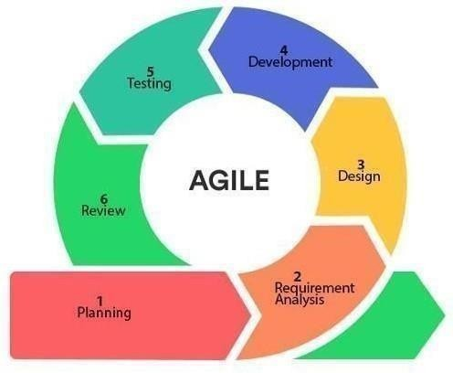

Figure 3.5. Agile Mode

# CHAPTER 4

**SOFTWARE REQUIREMENT SPECIFICATION AND**

## **ANALYSIS**

###### Purpose

The purpose of the DSA Profiler is to serve as a comprehensive solution to the perennial strugglefaced by students and professionals alike in mastering DSA. The project aims to create a dynamicplatform that not only identifies areas of improvement but also facilitates a targeted approach towards enhancing one's proficiency in solving DSA problems.

###### Scope

The scope of the DSA Profiler extends beyond being a mere assessment tool. It encompasses multifaceted approach, integrating elements of education, self-assessment, and personalized skill development. The project will involve the creation of a user-friendly web application that dynamically adapts to the user's skill level, offering a tailored learning experience

###### Definitions, Acronyms, and Abbreviations

SRS: Software Requirements Specification UI: User Interface

API: Application Programming Interface

#### FUNCTIONAL REQUIREMENTS

###### User Registration and Authentication

* + - * Users must be able to register with the system, providing necessary details.

###### Problem Repository

* + - * The profiler should have a repository of DSA problems categorized by difficulty level, data structure, and algorithmic concept.
      * Each problem should include a description, input-output examples, and constraints

###### Leader board:

* + - * Implement a leaderboard to encourage healthy competition among users.
      * Display rankings based on factors like accuracy, efficiency, and overall problem- solving skills.

#### NON-FUNCTIONAL REQUIREMENTS

###### Security

* + - * Encryption: All communication (data in transit) must be encrypted using HTTPS.
      * Access Control: Role-based access control to ensure data privacy and security.

###### Performance

* + - * Response Time: The system should provide responses within 3 seconds for typical userinteractions.
      * Scalability: The system must handle a concurrent user load of at least 500 users.

###### Portability

* + - * Cross-Browser Compatibility: The system should be compatible with major browsers(Chrome, Firefox, Safari, and Edge).

###### Mobile Responsiveness

* + - * Ensure the system is accessible and functional on various devices (smartphones, tablets).

###### Reliability

* + - * Uptime: The system should aim for 99.9% uptime.
      * Data Backup: Regular automated backups of user and appointment data.

###### Reusability

* + - * Modularity: Codebase should be modular to facilitate future enhancements or feature additions.

###### Application Compatibility

* + - * Integration: Compatibility with external systems such as pharmacy services and healthdatabases.

###### Data Integrity

* + - * Data Validation: Ensure accurate and valid data inputs during user interactions.
      * Data Logging: Log all user interactions and system events securely.

###### Scalability Capacity

* + - * Load Balancing: Implement load balancing for efficient resource utilization.
      * Scalable Architecture: Design the system to scale horizontally as user demand increases.

#### DESIGN CONSTRAINTS

###### Technology Stack

* + - * Frontend: React.js
      * Backend: Next.js/Node.js with Express.js
      * Database: MongoDB

###### 4.2.2 Real-time Analysis:

* Support real-time analysis to provide instant feedback on code performance.
* Implement features like step-by-step execution analysis and dynamic profiling.

#### CONCLUSION

The Software Requirements Specification outlines the functional and non-functional requirements, design constraints, and critical aspects of the "Data Structure Profiler" Online DSA problem solving system. This document serves as a guideline for the development team to ensure the successful implementation of the proposed software.

# CHAPTER 5 RISK ASSESSMENT

#### PROJECT RISKS

###### Technical Complexity

Likelihood: High

Consequence: Delayed project timeline, increased development costs.

Risk Avoidance: Conduct thorough technology feasibility studies before project initiation.Risk Reduction: Employ skilled developers with experience in the chosen technology stack.

###### Integration Challenges

Likelihood: Medium

Consequence: System malfunctions, data inconsistencies.

Risk Avoidance: Conduct comprehensive testing during integration phases.Risk Reduction: Use standardized data exchange formats and protocols.

###### User Adoption

Likelihood: Medium

Risk Avoidance: Conduct user feedback sessions during development.

Risk Reduction: Implement an intuitive user interface, provide user training materials.

#### SECURITY AND COMPLIANCE RISKS

###### HIPAA Compliance Violation

Likelihood: Medium

Consequence: Legal penalties, damage to reputation.

#### OPERATIONAL RISKS

###### Downtime

Likelihood: Medium

Consequence: Disrupted services, user frustration.Risk Containment:

Risk Avoidance: Implement redundant server infrastructure. Risk Reduction: Regular maintenance during low usage periods.

###### Insufficient Scalability

Likelihood: High

Consequence: Poor system performance, frustrated users.Risk Containment: Risk Avoidance: Conduct scalability testing during development.Risk Reduction: Implement elastic scaling solutions.

#### EXTERNAL RISKS

###### Regulatory Changes

Likelihood: Low

Consequence: Changes in compliance requirements, project delays.Risk Containment: Risk Avoidance: Stay informed about healthcare regulations.

Risk Transfer: Regularly consult legal experts for compliance updates.

###### Third-Party Service Reliability

Likelihood: Medium

Consequence: Service interruptions, impact on functionality.Risk Containment: Risk Avoidance: Select reputable third-party services.

Risk Reduction: Implement fallback mechanisms for critical functionalities.

#### RISK MITIGATION STRATEGIES

###### Risk Mitigation Planning

Risk Avoidance: Identify and eliminate risks at the early stages of project planning.Risk Transfer: Utilize insurance and legal mechanisms to transfer specific risks.

Risk Reduction: Implement measures to minimize the impact or likelihood of identified risks.

###### Continuous Monitoring and Evaluation

Establish regular risk assessment reviews throughout the project lifecycle. Monitor external factors, such as changes in healthcare regulations, and adjust risk strategiesaccordingly.

###### Contingency Planning

Develop contingency plans for high-impact risks, ensuring swift responses to mitigate consequences.

Maintain a comprehensive disaster recovery plan in case of major system failures.

## **CHAPTER 6**

## **DATA FLOW DIAGRAM**

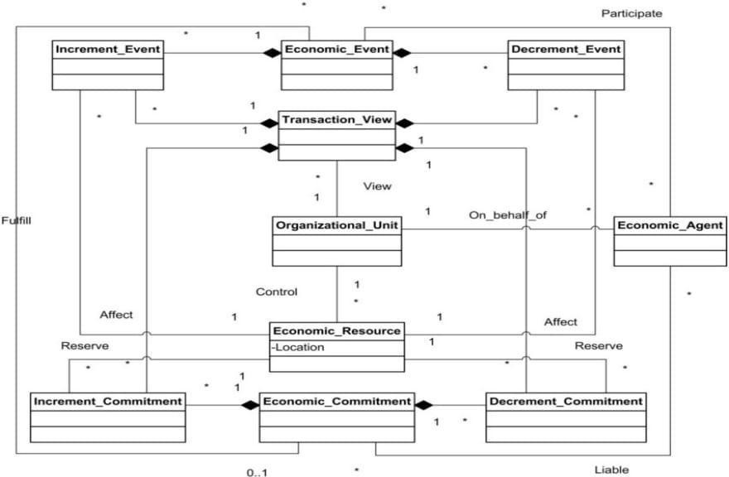

## **CHAPTER 7**

## **SOFTWARE FEATURES**

* Algorithm Profiling: Provide the ability to profile and analyze the efficiency of different algorithms.
* Code Editor and Execution Environment: Include an integrated code editor for users to write and execute DSAcode. Support multiple programming languages commonly used for DSA (e.g., C++, Java, Python).
* Problem Repository: Curate a repository of DSA problems categorized by difficulty.
* Automated Code Analysis: Implement a feature that analyzes and evaluates the correctness and efficiency of user-submitted code.
* Performance Metrics: Display detailed performance metrics for code execution, including runtime, memory usage, and any relevant benchmarks.
* Interactive Visualization: Incorporate visualizations for algorithms and data structures to aid in understanding.
* Learning Paths and Tutorials: Create guided learning paths or tutorials for users to improve their DSA skills progressively.
* User Profiles and Progress Tracking: Allow users to create profiles and track their progress over time.
* Community Features: Enable users to discuss problems, solutions, and best practices.
* Customizable Coding Environments: Support the integration of external libraries and frameworks.
* Code Versioning: Integrate basic version control features for users to track changes in their code submissions.
* Mobile Compatibility: Develop a responsive design to ensure usability on various devices.
* Performance Benchmarking: Include a benchmarking feature that compares user solutions against optimal or community-standard solutions.
* Gamification Elements: Introduce gamification elements, such as badges, achievements, or a point system, tomotivate users.
* Offline Mode: Allow users to download problems and solutions for offline practice.
* Multi-Language Support: Offer the interface in multiple languages to cater to a diverse user base.19.

## **CHAPTER 8**

### **TESTING AND EVALUATIONS**

1. Unit Testing for Data Structures and Algorithms:
   * Explanation: Unit tests verify individual components such as data structures and algorithms to ensure their correctness and functionality.
   * Example: Writing test cases to validate insertion, deletion, and searching operations on data structures like linked lists and binary search trees, along with sorting algorithms. Ensuring that searching operations return the correct results for various input scenarios.
2. Integration Testing for Sorting Algorithms:
   * Explanation: Integration tests ensure that different components interact seamlessly within the system.
   * Example: Creating tests to validate that sorting algorithms correctly sort data structures like arrays or linked lists, and that search operations on sorted data return accurate results.
3. System Testing for User Input Handling and Search Functionality:
   * Explanation: System tests evaluate the behavior of the entire system, including user interactions and search functionality.
   * Example: Simulating user inputs such as adding, updating, or deleting data structures and algorithms, and verifying that search functionality returns relevant results. Testing scenarios where users search for specific data structures or algorithms and ensuring the system displays accurate search results.
4. Performance Testing for Sorting Efficiency:
   * Explanation: Performance tests assess the speed and efficiency of algorithms and data structures under different conditions.
   * Example: Measuring the time complexity of sorting algorithms for various input sizes and analyzing the impact of input size on search performance. Ensuring that sorting

and searching operations maintain acceptable performance levels even with large datasets.

1. User Acceptance Testing (UAT) for Interface Usability:
   * Explanation: UAT involves real users evaluating the system to ensure it meets their needs and is user-friendly.
   * Example: Involving stakeholders or target users to interact with the interface across multiple screens, performing tasks like adding, updating, or searching for data structures and algorithms. Gathering feedback on the clarity of instructions and ease of use across different screen sizes and resolutions.
2. Regression Testing for Algorithm Modifications:
   * Explanation: Regression tests verify that recent changes to the codebase have not introduced new defects or affected existing functionalities.
   * Example: After modifying existing algorithms or introducing new features, running regression tests to ensure that sorting and searching functionalities still produce correct results. Ensuring that changes to sorting algorithms do not adversely affect search performance.
3. Security Testing for Input Validation:
   * Explanation: Security tests identify vulnerabilities and ensure the protection of sensitive data.
   * Example: Testing input fields for proper validation to prevent security risks such as SQL injection attacks or cross- site scripting (XSS) vulnerabilities. Ensuring that search queries are sanitized to prevent potential security threats.

## **CHAPTER 9**

## **PROJECT SNAPSHOTS**

* 1. **FRONT PAGE**

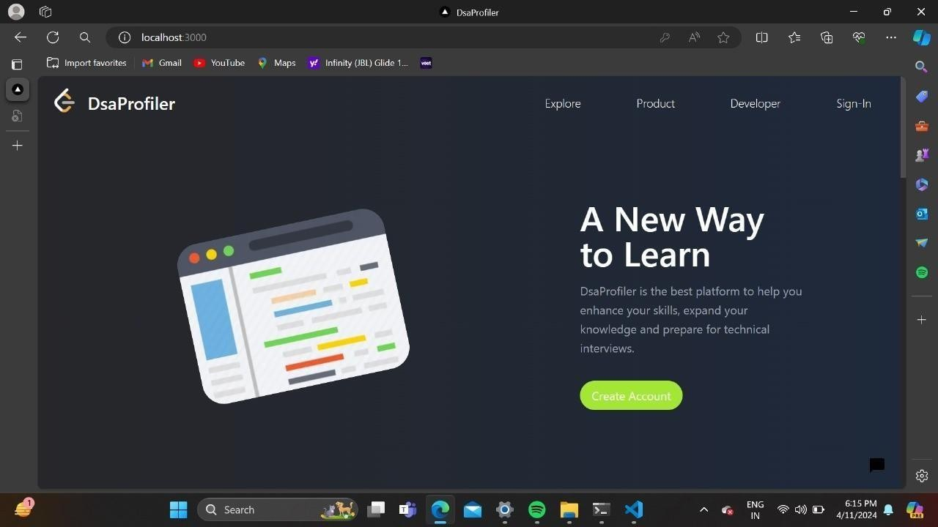

### 

### Fig 9.1 Front Page

## **SIGNUP PAGE**

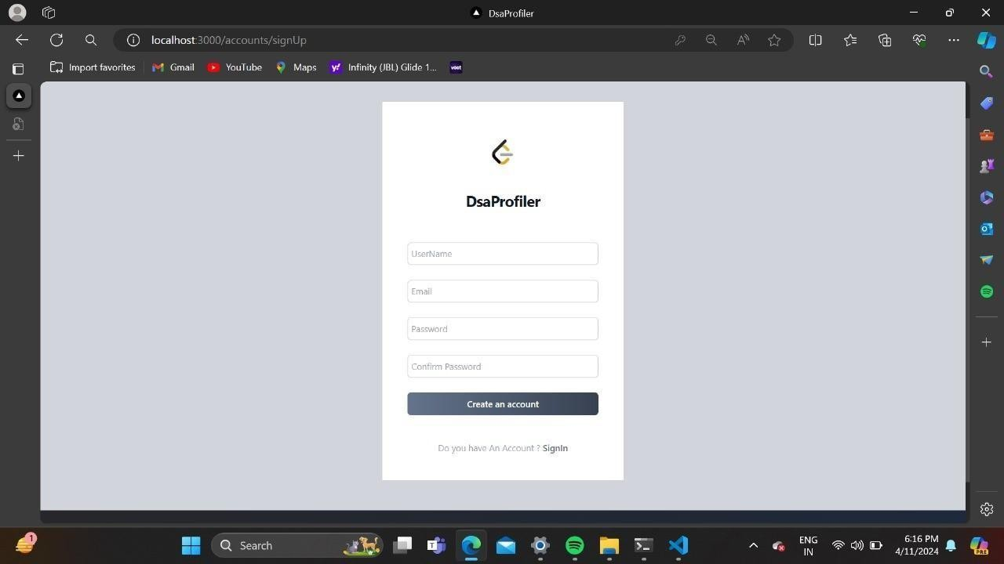

### Fig 9.2 Signup Page

### **LOGIN PAGE**

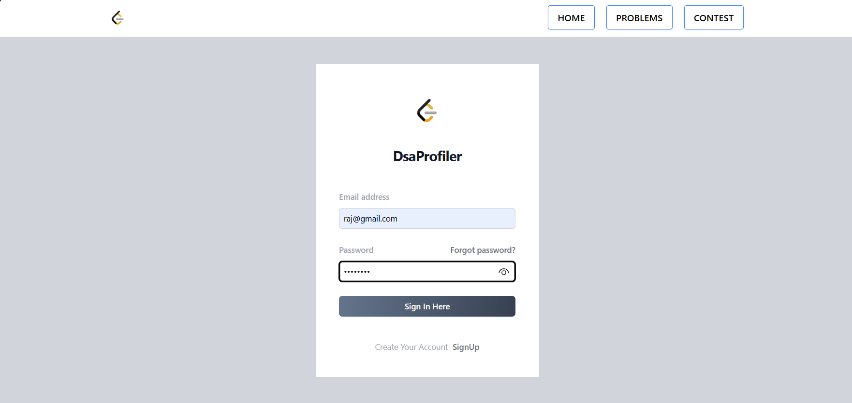

Fig 9.3 Login Page

**9.4 MAIN PAGE**

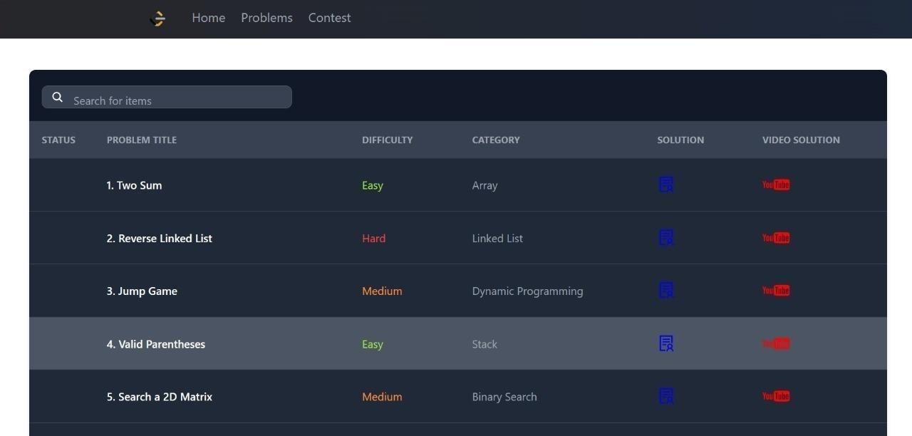

Fig 9.4 Main Page

### **9.5 PROBLEM SOLVING DISPLAY**

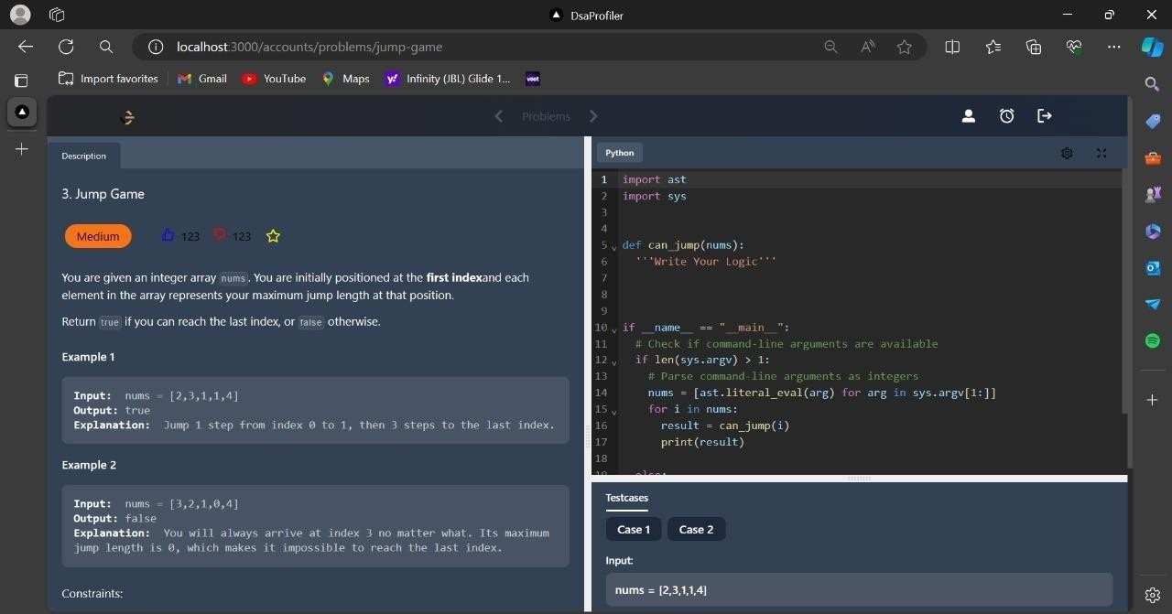

Fig 9.5 Problem solving display

**9.6 CHATBOT**

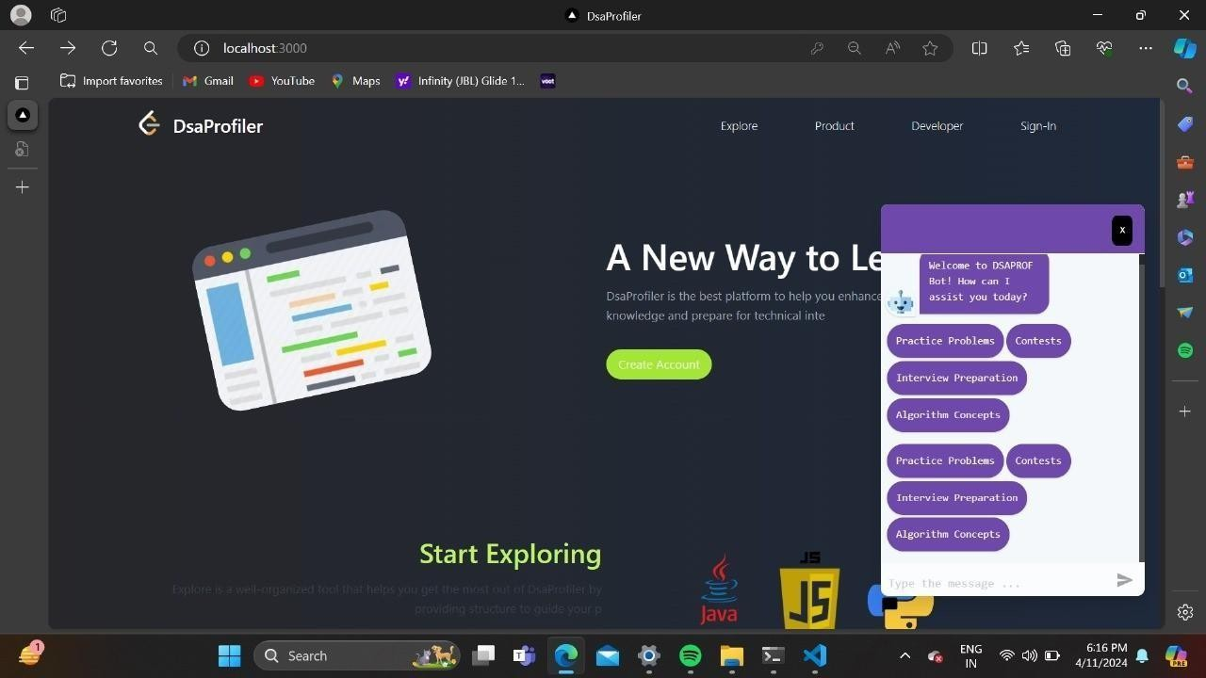

Fig 9.6 Chat Bot

**9.7 DASHBOARD**

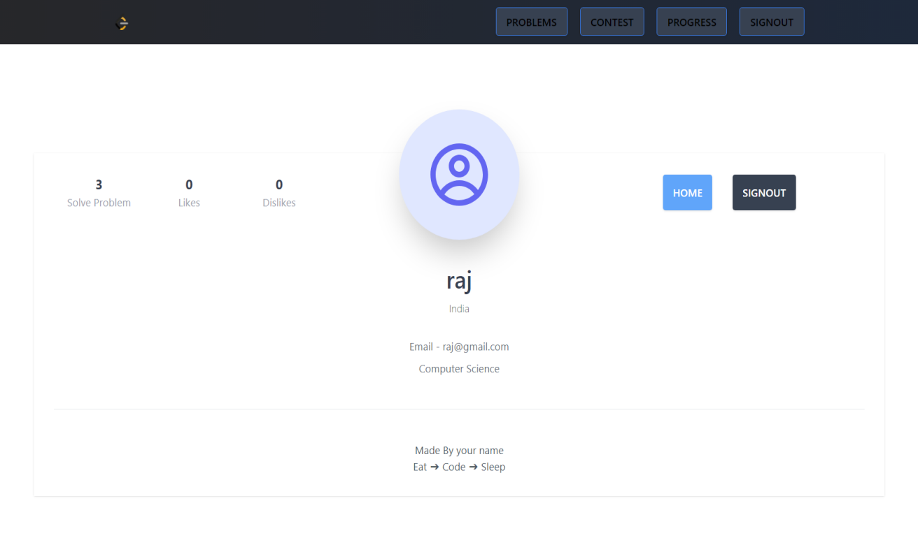

Fig 9.7 Dashboard

**9.8 PROGRESS CHART**

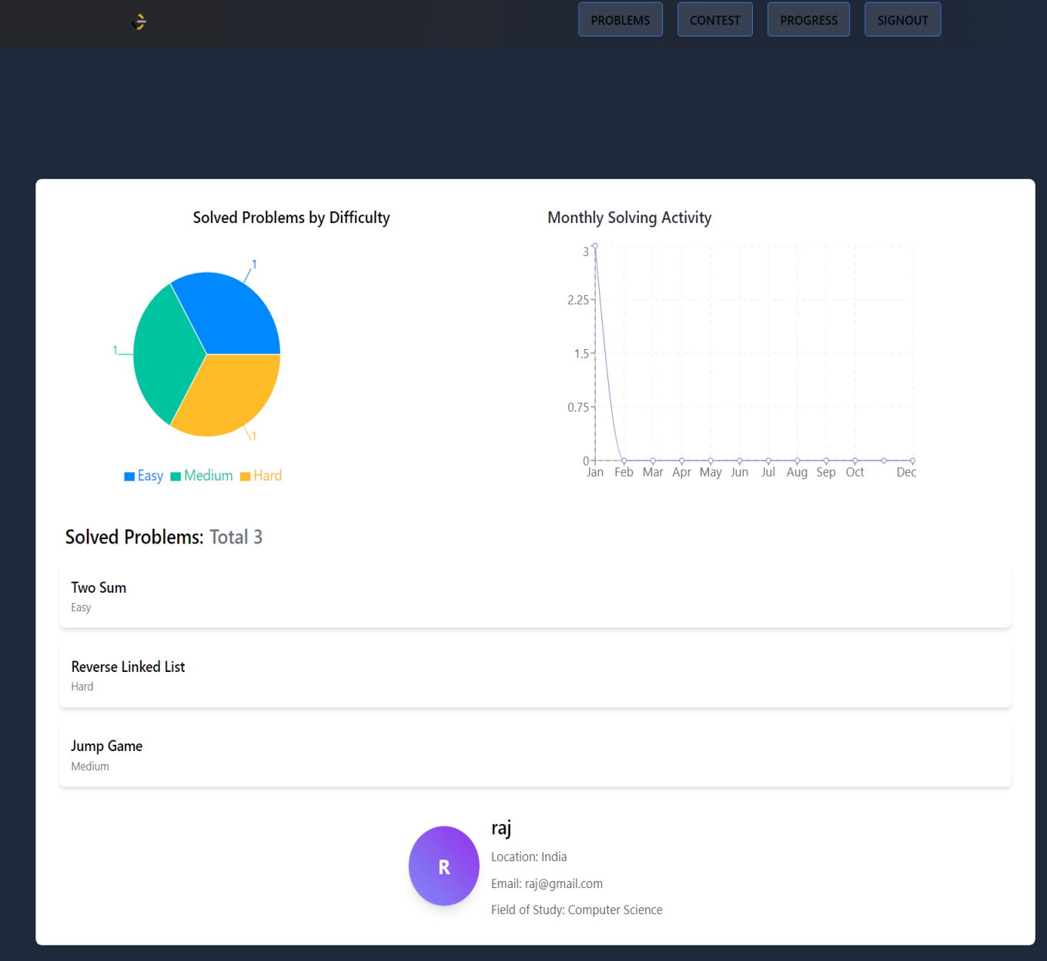

Fig 9.8 Progress Chart

**9.9 TESTCASES PASSED**

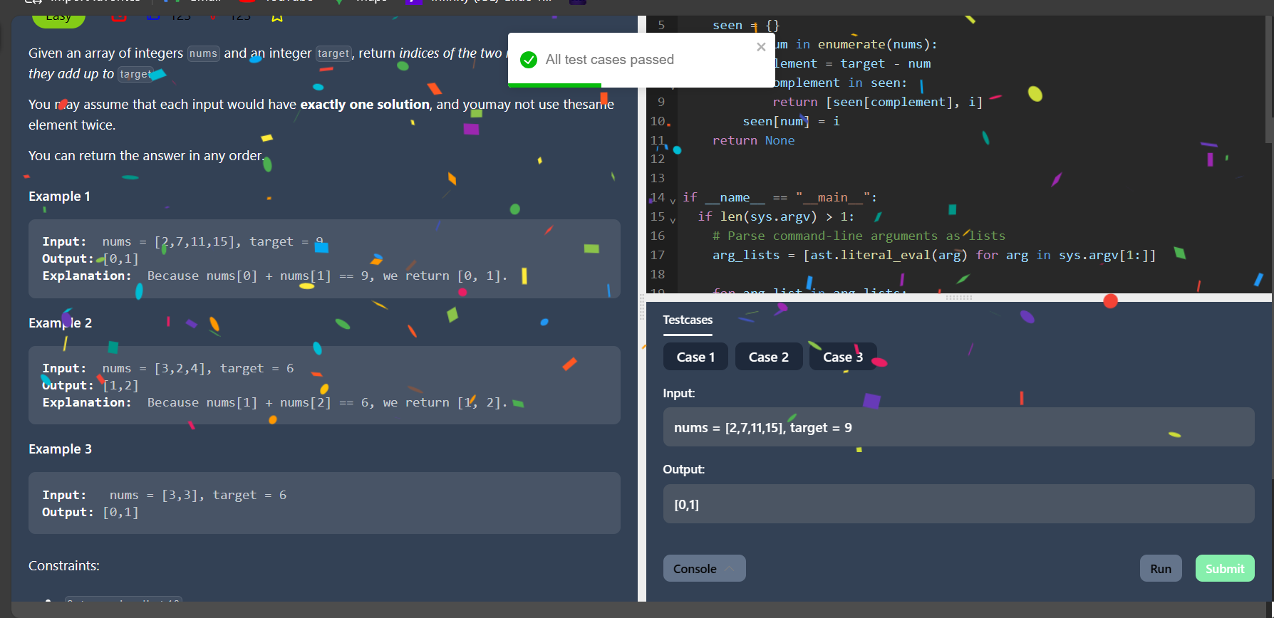

Fig 9.9 Testcases Passed

**9.10 VIDEO SOLUTION**



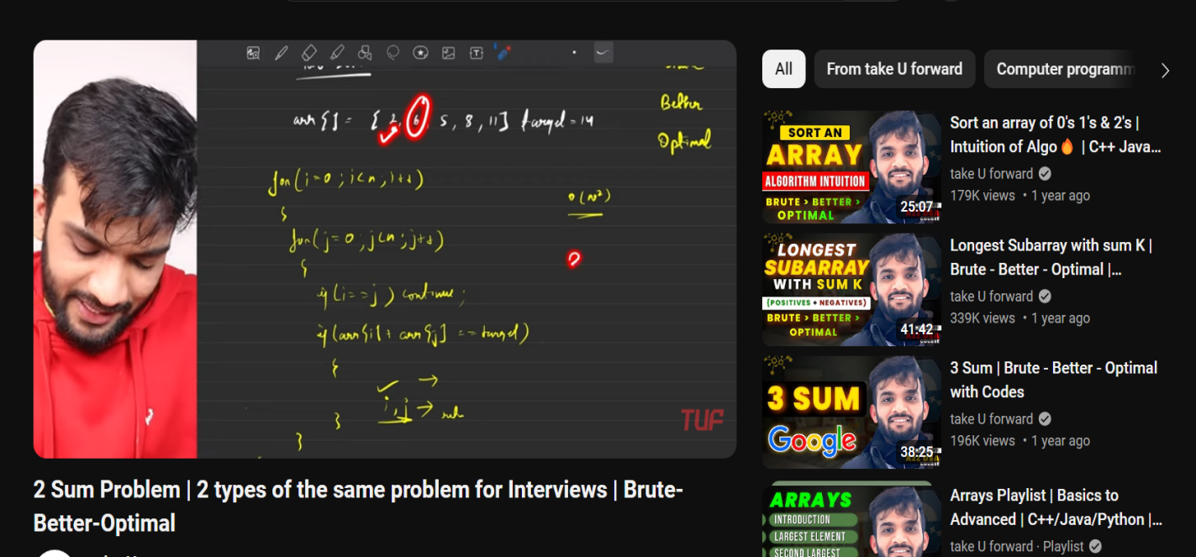

Fig 9.10 Video Solution

## **CHAPTER 10**

### **LIMITATION**

* + 1. Reliance on Technological Infrastructure:

This limitation pertains to the necessity of users having consistent access to high- speed internet and up-to-date computing devices to fully utilize the platform's features.

In regions with inadequate internet infrastructure or for individuals with limited access to technology, the platform may be inaccessible or its functionality compromised.

Mitigation strategies could involve optimizing the platform for low-bandwidth connections or developingoffline functionalities where feasible.

* + 1. Technology Adoption Learning Curve:

The integration of various technologies, such as the MERN stack (MongoDB, Express.js, React, Node.js) andAI for the chatbot, demands a certain level of expertise from developers and educators.

For those unfamiliar with these technologies, the learning curve may be steep, potentially slowing down theadoption rate of the platform.

Providing comprehensive documentation, tutorials, and training programs can help alleviate this barrier byfacilitating skill acquisition and implementation support.

* + 1. Scalability Considerations:

While the MERN stack is known for its scalability, the platform's real-world scalability, particularly underheavy user loads, remains untested.Unexpected technical challenges, such as database bottlenecks or server overload, could arise as the user baseexpands, affecting the platform's performance and user experience .Conducting thorough stress testing and implementing scalable architecture designs are essential to addresspotential scalability issues preemptively.

* + 1. Content Quality and Diversity:

The effectiveness of the platform heavily relies on the quality, relevance, and diversity of its educationalcontent .Ensuring a comprehensive repository of problem sets and learning materials that cater to various expertiselevels and educational standards is a continuous challenge.Continuous content curation, collaboration with subject matter experts, and leveraging user feedback mechanisms can help maintain content quality and relevance over time.

* + 1. Balancing Personalization and Generalization:

The chatbot's aim to deliver personalized feedback presents a delicate balance between tailored guidance and universally applicable insights.

Striking this balance is challenging, as overly generic feedback may lack impact, while overly specific feedback may not resonate with all users.

Implementing adaptive algorithms that tailor feedback based on user interaction patterns and preferences can enhance the platform's ability to provide personalized yet broadly relevant guidance.

* + 1. Balancing Personalization and Generalization:

The chatbot's aim to deliver personalized feedback presents a delicate balance between tailored guidance and universally applicable insights.

Striking this balance is challenging, as overly generic feedback may lack impact, while overly specific feedback may not resonate with all users.

Implementing adaptive algorithms that tailor feedback based on user interaction patterns and preferences can enhance the platform's ability to provide personalized yet broadly relevant guidance.

* + 1. Balancing Personalization and Generalization:

The chatbot's aim to deliver personalized feedback presents a delicate balance between tailored guidance and universally applicable insights.

* + 1. Balancing Personalization and Generalization:

The chatbot's aim to deliver personalized feedback presents a delicate balance between tailored guidance and universally applicable insights.

Striking this balance is challenging, as overly generic feedback may lack impact, while overly specific feedback may not resonate with all users.

Implementing adaptive algorithms that tailor feedback based on user interaction patterns and preferences can enhance the platform's ability to provide personalized yet broadly relevant guidance.

* + 1. User Engagement and Motivation:

Sustaining user engagement and motivation over time is crucial for the platform's long-term success.

Understanding the diverse motivations of users from different backgrounds and demographics, and how these motivations evolve, is essential but challenging.Employing gamification techniques, personalized learning paths, and regular feedback mechanisms can foster user engagement and motivation, but ongoing research and user feedback analysis are necessary to refine these strategies effectively.

## **CHAPTER 11**

### **FUTURE SCOPE**

1. Enhancing the Chatbot
   * Implement advanced machine learning algorithms and natural language processing (NLP) techniques.
   * Integrate sentiment analysis for better understanding of user queries.
   * Provide personalized and tailored responses to improve user experience.
2. Expanding the Problem Set:
   * Continuously add new data structures, algorithms, and programming concepts.
   * Cater to users with varying expertise levels, from beginners to advanced learners.
   * Ensure a comprehensive learning experience for all users.
3. Integrating with Educational Institutions:
   * Collaborate with schools and universities to integrate the platform into curricula.
   * Customize platform features to align with specific course objectives.
   * Provide educators with tools for monitoring student progress.
4. Conducting Longitudinal Studies:
   * Evaluate the platform's long-term impact on users' learning outcomes.
   * Assess the development of problem-solving skills over time.
   * Identify areas for improvement based on study findings.
5. Improving User Engagement:
   * Implement gamification elements such as leaderboards and badges.
   * Create interactive challenges to maintain user interest.
   * Foster a sense of community through social features and collaboration opportunities.
6. Enhancing Accessibility:
   * Implement features for users with disabilities, such as screen reader compatibility.
   * Ensure keyboard navigation for ease of use.
   * Provide alternative text for images to accommodate visually impaired users.
7. Internationalization and Localization:
   * Translate content into multiple languages.
   * Incorporate culturally relevant examples and scenarios.
   * Ensure cultural sensitivity in the platform's interface and content.
8. Enhancing Data Privacy and Security:
   * Strengthen encryption protocols to protect user information.
   * Ensure compliance with data protection regulations.
   * Regularly audit the platform for security vulnerabilities and address them promptly.
9. Continued Research and Development:
   * Collaborate with researchers, educators, and industry experts.
   * Incorporate cutting-edge practices and methodologies into the platform.
   * Stay updated on the latest trends and technologies in data structures education.
10. Feedback and Iterative Improvement:
    * Solicit feedback from users through surveys and analytics.
    * Actively engage with the user community to gather insights.
    * Use feedback to make iterative improvements to the platform, ensuring its continued relevance andeffectiveness.

### **CONCLUSION**

Considering the future trajectory of this innovative platform, it's evident that its impact could extend far beyond individual learners. By bridging the gap between theoretical knowledge and practical application, the platform has the potential to transform the way data structures are taught and learned in educational institutions worldwide.

One of its key strengths lies in its adaptability and scalability. As it evolves, the platform can be tailored to meet the specific needs of different educational settings, from K-12 schools to higher education institutions and professional development programs. This adaptability opens up a wide range of possibilities for integrating the platform into existing curricula and learning frameworks, thereby enhancing the effectiveness of data structures education across diverse contexts.

Furthermore, the platform's emphasis on collaboration and community engagement offers a unique opportunity to foster a culture of learning and knowledge sharing among users. By providing tools for collaboration, such as discussion forums, group projects, and peer review features, the platform can facilitate meaningful interactions and foster a sense of belonging within the learning community.

In addition to its educational impact, the platform also has the potential to drive innovation in the field of data structures and algorithms. By providing a platform for users to experiment with new ideas, explore innovative solutions, and share their findings with others, the platform can contribute to the advancement of knowledge in this critical area of computer science.

Overall, the future of this platform is promising, with the potential to make a lasting impact on the way data structures are taught, learned, and applied. By embracing innovation, collaboration, and inclusivity, the platform has the opportunity to empower learners of all backgrounds and abilities to excel in the field of data structures and beyond

**REFERENCES**

1. M. J. Salganik and D. Watts. “Leading the Herd Astray:A Data Structure And Structure Tracker” Social Psychology Quarterly, 71:338-

-355, December 2011.

1. G. Szabo and B. A. Huberman. “The Algorithms for Multiple-Target Tracking ACM”, 53(8):80--88,August 2020.
2. R. Zhou, S. Khemmarat, and L. Gao. “The Impact of Data Structure In the Today’s world”. In Proc. ACM Internet Measurement Conference (IMC), pages 404--410, Melbourne, Australia, November 2019.
3. F. Figueiredo, F. Benevenuto, and J. M. Almeida “Tracking of The Question in the Website”. In Proc. ACM International Conference on Web Search and Data Mining (WSDM), pages 745-- 754, Hong Kong, China, February 2021.
4. Trandisauskas, N.; Juhl, J.; Lahrmann, H.; Jensen, C.S. “Automated

Tracking”. IET Intell.Transp. Syst. 2009, 3, 57–66. Carsten ,O.M.;

Tate, F. Intelligent speed adaptation: Accident savings and cost–benefit analysis. Accid. Anal.Prev. 2005, 37, 407–416.

[6] Vlassenroot, S.; Broekx, S.; De Mol, J.; Panis, L.I.; Bris, T.; “Leading the Herd Astray:A DataStructure And Structure Tracker” 2007, 41, 267–279.

[7] Lai, F.; Carsten, O.; Tate, F. “The Importance of Data Structure In the Today’sworld.”. Accid.Anal. Prev. 2012, 48, 63–72.

**ACCEPTANCE CERTIFICATE**

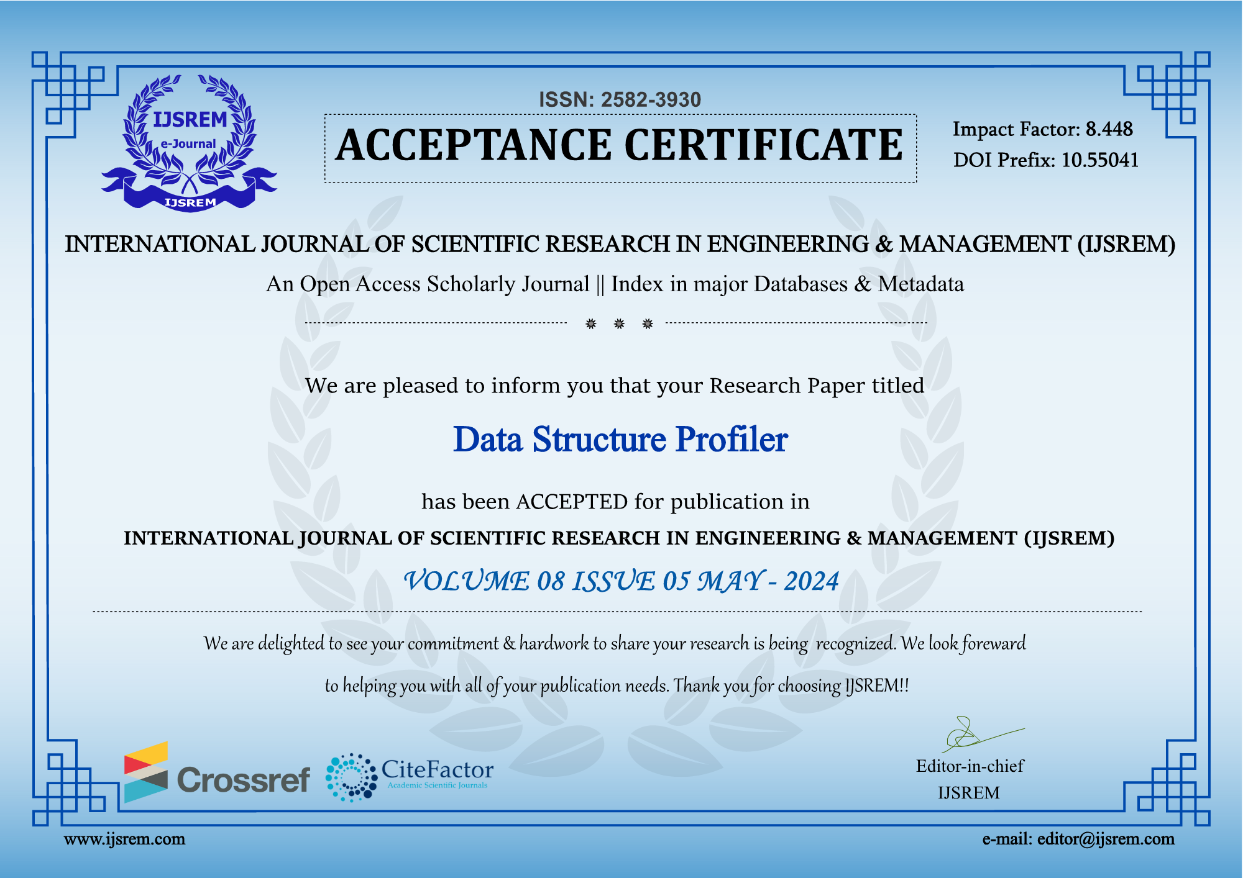

**PUBLICATION CERTIFICATE**

